Project By:
Shreya Sinha Roy
ssr.shreyasinharoy@gmail.com
Microsoft Case Study: ChatGPT vs Claude vs Gemini
Generative AI for Financial Forecasting

Table of Contents
1. Project Overview 2
2. LLM Comparative Analysis 2
3. ChatGPT—Analysis & Visual Output 3
4. Claude—Analysis & Visual Output 4
5. Gemini—Analysis & Visual Output 6
6. Key findings & Conclusion 8

Project Overview
This project compares how ChatGPT, Claude, and Gemini approach the same financial forecasting task using Microsoft’s historical financial data. The analysis focuses on Revenue and COGS trends, gross profit forecasting, key assumptions, forecasting methods, and how easy each model’s output is to interpret.
Each LLM followed a different approach. Some relied on historical YoY growth trends, while others used more advanced statistical and ensemble forecasting methods. This made it possible to compare their strengths, limitations, level of sophistication, and overall usefulness from a financial analyst’s perspective.
The report also includes screenshots of the charts, forecasts, and visual outputs generated by each model, making it easier to compare not just the numbers, but also how clearly each LLM presented and explained its analysis.

LLM Comparative Analysis

Parameter | ChatGPT | Claude | Gemini
Revenue & COGS Trend Analysis | - Calculated Revenue and COGs trend – Annualized growth rate derived.  - Analyzed COGS as % of revenue Seasonality captured for month of December.  - Margin indication- identified December-quarter seasonality; observed positive operating leverage at the gross-profit level. | - Calculated Revenue and COGs trend growth rate.  - Analyzed COGS as % of revenue Seasonality captured for month of December.  - Gross Margin indication- interpreted the trend as improving gross-margin efficiency. | - Conducted detailed quarterly Revenue and Cost of Sales (COS) analysis.  - Calculated COGs as % Revenue and YoY growth or Revenue and COGs.  - Long-Term Revenue Growth (Accelerated Growth, Post-COVID Normalization (FY23), AI & Cloud Re-acceleration (FY24) and Seasonality captured.  - Gross Margin indication- suggesting improving cost efficiency.
Gross Profit Forecast Methodology | - Methodology: Gross Profit = Revenue – COS.  - Forecasted Forecast revenue and COGS using the average YoY growth rates of the latest four reported quarters. | - Methodology: Forecasted revenue and COGS separately, then derive gross profit.  - Applied the average year-over-year growth rate from the trailing 4 quarters to the same quarter one year prior. | - Methodology: 5 predictive models used for forecasting: Holt-Winters Exponential Smoothing, SARIMA, YoY Growth Momentum, Linear Trend with Seasonal Dummies, Margin-Based Model, Ensemble Consensus.
Key Forecast Assumption | - Recent revenue growth exceeds COGS growth, consistent with the recent historical pattern.  - Gross margins remain around 70–72%. | - Recent growth trend remains broadly persistent. Trend-extrapolated scenario produces margins up to 72–74% exceeding recent historical levels. | - Historical trend, seasonality, growth momentum and gross-margin behaviour collectively provide useful predictive signals.
Model Sophistication | - Moderate — transparent and easy to explain. | - Moderate–High — includes sensitivity to alternative trend assumptions. | - High — multiple statistical models and ensemble forecasting.
Interpretability | - Moderate — transparent and easy to explain. | - Moderate–High — includes sensitivity to alternative trend assumptions. | - High — multiple statistical models and ensemble forecasting.
LLM Strength | - Clear and easy to follow.  - Maintained strong financial interpretability, making the assumptions and calculations easy to validate. | - Strong assumption testing by identifying when extrapolated margins moved above historical levels. | - Comprehensive quantitative forecasting framework- Used the widest range of forecasting techniques
LLM Limitation | - Dependency on YoY growth and historical average growth rate. | - Trend extrapolation can produce overly optimistic margin assumptions when recent growth is extended too far. | - Greater model complexity makes the forecasting process less transparent and harder to independently replicate.

ChatGPT—Analysis & Visual Output
ChatGPT analysed Microsoft’s historical Revenue and COGS trends, identified seasonality and margin behaviour, and used recent YoY growth rates to forecast Revenue and COGS for the next four quarters. Gross Profit was then derived from the forecasted values. The screenshots below show the key analysis, forecast output, and visualizations generated during the process.

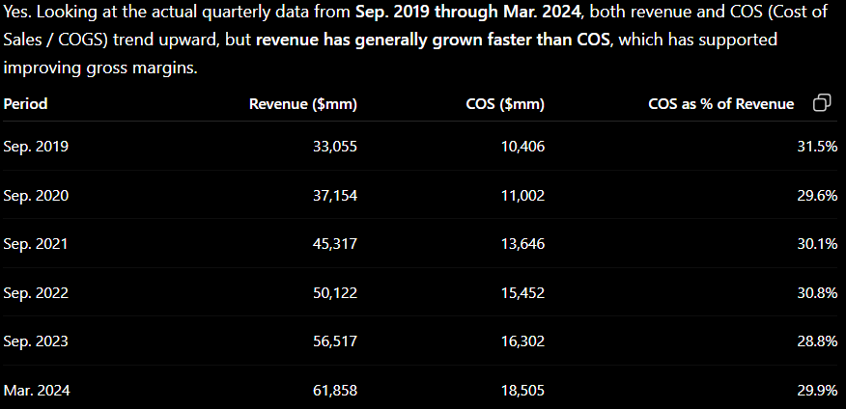
1. ChatGPT – Historical Revenue & COGS Analysis
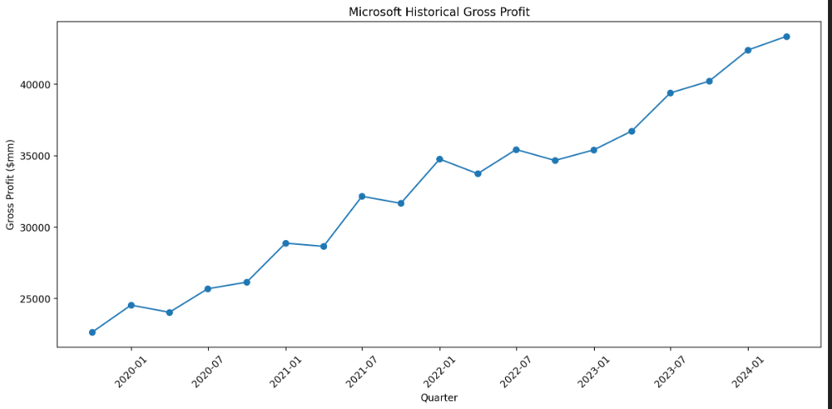
2 ChatGPT - Historical Gross profit

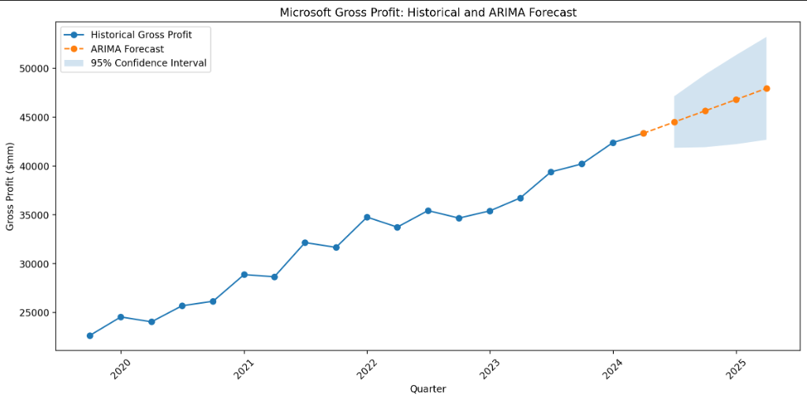
3 ChatGPT - ARIMA forecasted Gross profit
ChatGPT provided a clear and easy-to-follow forecast based on recent YoY growth trends. The approach was financially intuitive and easy to validate, although it relied heavily on the assumption that recent Revenue and COGS growth patterns would continue.

Claude—Analysis & Visual Output

Claude analysed Microsoft’s historical Revenue and COGS trends, reviewed seasonality and gross-margin behaviour, and forecasted Revenue and COGS separately using recent YoY growth rates. It also tested a trend-based scenario to assess whether continued growth could result in margins moving beyond recent historical levels. The screenshots below show Claude’s analysis, forecast output, and visualizations.
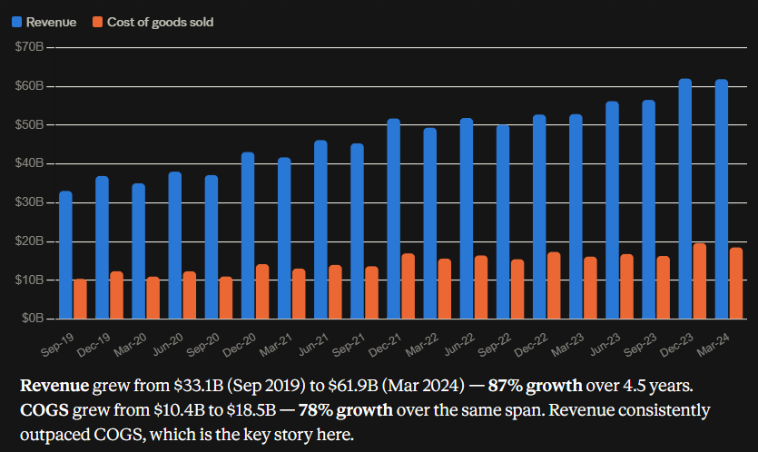
4 Claude – Historical Revenue & COGS Analysis

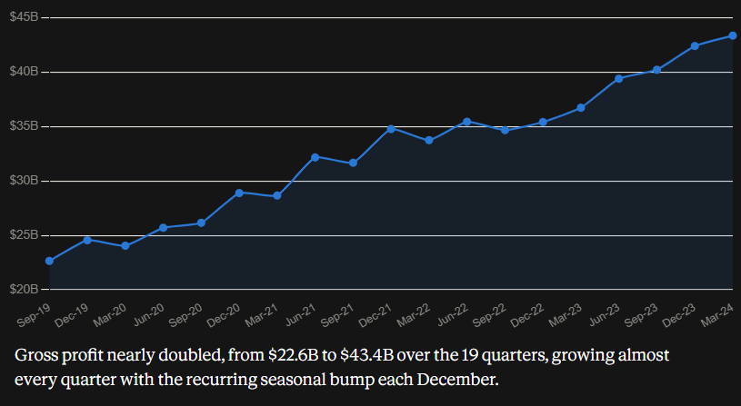
5 Claude - Historical Gross profit

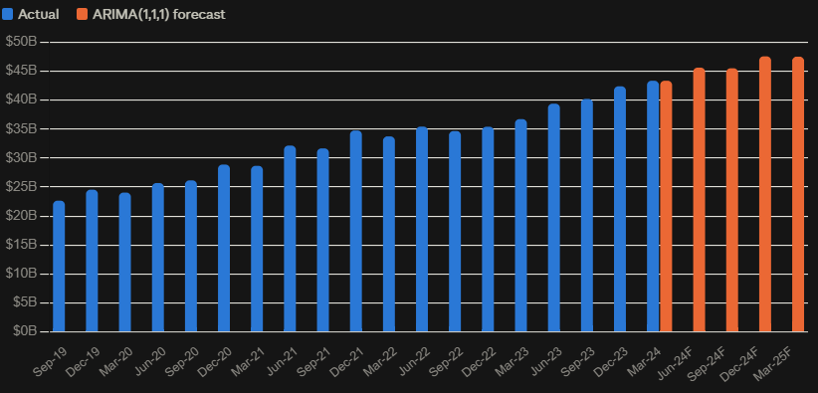
6 Claude - ARIMA forecasted Gross profit
Claude provided a clear forecasting approach and added value by testing how far recent growth trends could reasonably be extended. Its analysis was particularly useful in highlighting that trend-based forecasts can become too optimistic when projected margins move above recent historical levels. This makes Claude’s output useful from a financial analyst’s perspective because it not only generates a forecast, but also challenges whether the result is financially reasonable.

Gemini—Analysis & Visual Output
Gemini analysed Microsoft’s historical Revenue and COGS trends, YoY growth, seasonality, and gross-margin behaviour. For forecasting, it used multiple statistical approaches, including Holt-Winters, SARIMA, YoY Growth Momentum, Linear Trend with Seasonal Dummies, and a Margin-Based Model, before combining the results through an ensemble forecast. The screenshots below show Gemini’s analysis, forecast output, and visualizations.
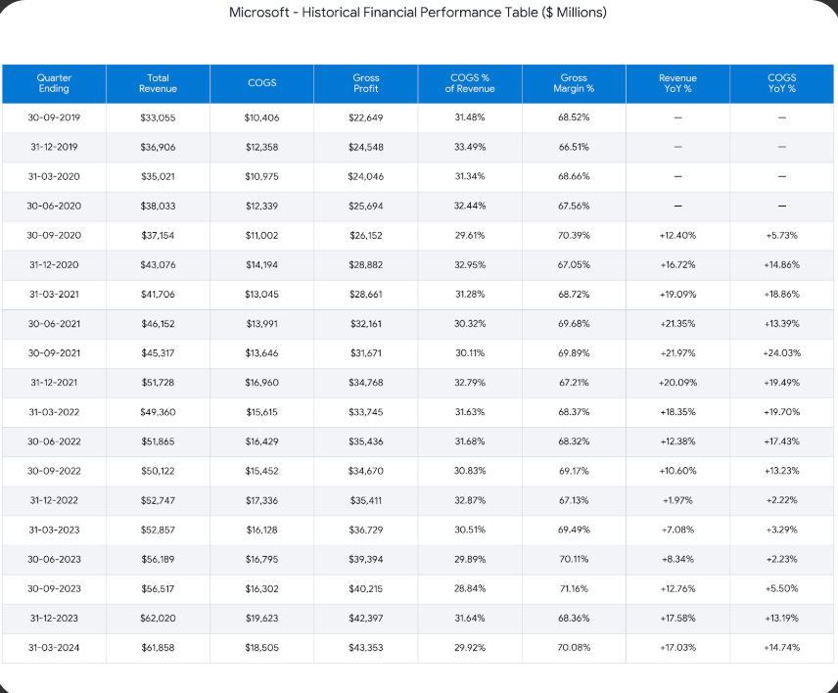
7 Gemini – Historical Revenue & COGS Analysis

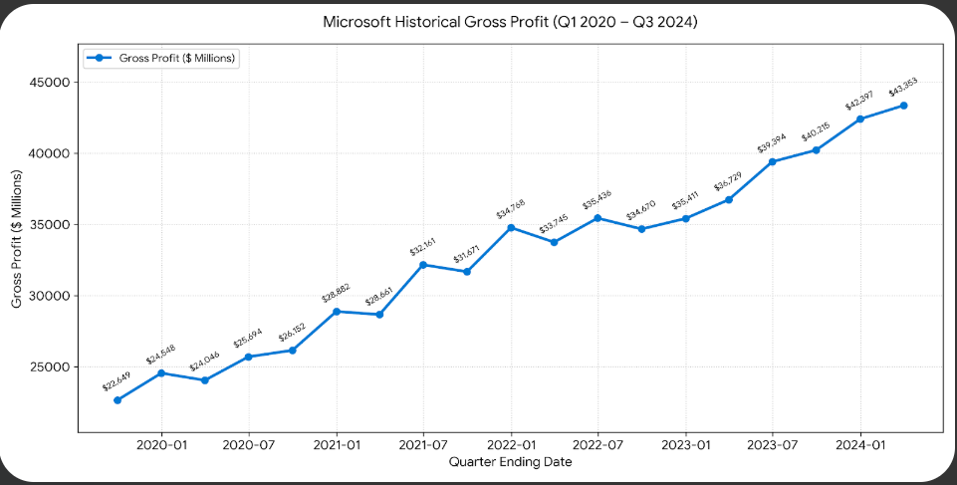
8 Gemini - Historical Gross profit

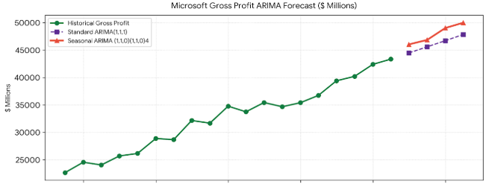
9 Gemini - ARIMA forecasted Gross profit

Gemini used the most comprehensive forecasting approach, combining multiple statistical models such as Holt-Winters, SARIMA, YoY Growth Momentum, Linear Trend with Seasonal Dummies, and a Margin-Based Model. It then used an ensemble approach to combine the outputs. This provided greater quantitative depth and captured trend and seasonality more extensively. However, the methodology was more complex, which made the forecast less transparent and harder to independently validate compared with the other two models.

Key findings & Conclusion

- Revenue and COGS Relationship Shows Positive Gross Margin Trend
Revenue has generally grown faster than COGS, indicating improving gross margins (around 70–72%) and positive operating leverage. However, this may not persist due to changes in costs, competition, or AI-related investments.

- Seasonality Is an Important Component of Quarterly Forecasting
Microsoft shows recurring December-quarter seasonality, meaning quarterly results must be compared year-on-year and across similar quarters, not just sequentially. Ignoring this can distort growth interpretation. Gemini explicitly models this using Holt-Winters, SARIMA, and seasonal dummies.

- The Three LLMs Demonstrated Different Levels of Forecasting Sophistication
One of the most significant observations from the comparison is that the models approached the same financial dataset using materially different methodologies.

ChatGPT: Simple YoY growth-based forecasting
Claude: YoY forecast + trend-based scenario analysis
Gemini: Multi-model ensemble (Holt-Winters, SARIMA, momentum, trend, margin model)

From a financial analyst perspective, this demonstrates an important trade-off:

Increasing model sophistication can improve the breadth of analysis, but it can also reduce transparency and make the forecast more difficult to independently validate.

Therefore, the most sophisticated model should not automatically be considered the most appropriate model.

- Financial Reasonableness Matters More Than Pure Statistics
Claude’s trend-based scenario produced above-historical gross margins (72–74%), highlighting that statistical extrapolation can become unrealistic. Forecasts must be checked against business logic, cost structure, and historical behaviour.

- Interpretability Is Critical
Simple, explainable models (ChatGPT, Claude) are easier to communicate to stakeholders than complex frameworks (Gemini). In financial settings, clarity and explainability often matter as much as accuracy.

- Every Forecasting Approach Carries Model Risk
Each model also demonstrated a distinct limitation.

ChatGPT: Relies heavily on recent growth continuation
Claude: Risk of overly optimistic trend extrapolation
Gemini: Reduced transparency due to complexity

The best model is not the most advanced, but the most financially reasonable and fit-for-purpose.

